Gaza Maritime Archaeology Project

**Introduction**

Lucy Blue, Maritime Director

In 2021 HFF awarded a grant to conduct the first of what later became two field seasons in coastal Gaza. The Gaza Maritime Archaeology Project (GAZAMAP) was developed as part of the Maritime Endangered Archaeology of the Middle East and North Africa (MarEA) project <https://marea.soton.ac.uk>, and is directed by Dr. Georgia Andreou, a MarEA research assistant based at the University of Southampton and Yasmeen Elkhoudary based at the Council of British Research in the Levant, UK.

A remote assessment conducted by the MarEA team of coastal Gaza, demonstrated the widespread impact of coastal erosion, building development, conflict and illicit digging on Gaza’s archaeological sites. This was the incentive for the team to seek support from the HFF to enable sites to be assessed on the ground. An initial reconnaissance undertaken by Yasmeen Elkhoudary of a selection of sites in December 2021-January 2022, confirmed the detrimental impact of these factors on the maritime archaeology. Preliminary discussions with the Deputy Department of Antiquities, Gaza (Ministry of Tourism and Antiquities) confirmed that archaeological sites were in urgent need of detailed documentation and protection. As a result, two seasons of field work have subsequently been conducted (2022, 2023) targeting the key sites of Tell es-Sakan (the largest archaeological site in Gaza) located north of Wadi Gaza and a series of Iron Age partly submerged coastal sites located to the south, including Tell Ruqeish, Tell Qatif and Tell Ridan.

# GAZAMAP is the first maritime archaeology project in the Gaza Strip since the 1970s and the first research archaeological project in this area since the early 2000s. It has successfully documented in detail, a number of key sites, expanding knowledge of the maritime archaeology of the region. It also works closely with local archaeologists and heritage professionals, journalists and media production companies and delivers training to archaeology and GIS students in the documentation of maritime archaeological features. The project was also supported by the University of Southampton Strategic Research Fund and was included in a successful funding application to the British Council, which recognised the potential of delivering specialised training in underwater heritage documentation.

**2023 Short Report**

Georgia Andreou, University of Southampton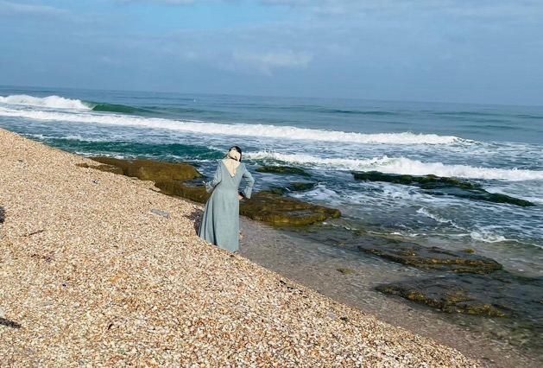 and Yasmeen Elkhoudary, Council of British Research in the Levant

**Staff**: Dr Ayman Hassouna (field director), †Rushdi Sarraj and †Ibrahim Lafti (aerial survey), Mohammed Asad Muhaisen (underwater survey)

**Students**: Tasnem Basem Al-Ashqar, †Moatasem Abdellatef Ahmed Habeeb, Janna Mohammed Haider, Ahmed Mohammed Mheisen, Reem Ahmed Ghanem, Mustafa Samir Badawi, Shaima Salah El-Dein Youssef Abu Jadallah, Sohaib Hisham Hussein Al-Kolak, Asmaa Muhammad Yusuf Shuhaiber, Sammar Jamal Salih Abu Shamas; Ahmed Alqotaty, Anas Aldabaj, Ali Shahwan, Hala Waleed, Asmaa Bakheet, Jamal Abdullah, Haneed Elmassry, Soliman Mohammed Abu Hasaneen, Mohammed Weshah, Sara Salman.

Contents

**Introduction** 1

**Training** 2

**Survey Results:** 3

**Community Engagement events** 6

**Collaborative research projects** 7

**Since October 2023** 7

**Media** 12

**Conclusions** 12

**Cited References** 13

# **Introduction**

The Gaza Maritime Archaeology Project (henceforth GAZAMAP) is the first maritime archaeology project in the Gaza Strip since the 1970s and the first research archaeological project in this area since the early 2000s. The project has concluded a successful first season in 2022, during which we trained eleven students to conduct a maritime survey at: (1) the Iron Age port city of Tell Ruqeish, and (2) a 4th millennium BCE Egyptian colony at Tell es-Sakan. The 2022 season expanded knowledge on Gaza’s maritime archaeology and introduced new themes in existing university curricula focusing on maritime archaeological skills. The preliminary results of GAZAMAP have produced updated site maps, raising the profile of maritime archaeology in Gaza.

The results of the 2022 season made clear that there are multiple undocumented submerged archaeological features across the coastline of Gaza. It also highlighted that, despite several restrictions in place, some spatial data collection technologies are available in Gaza, including drones and topographical survey equipment, both of which are used in the private sector. Bringing together heritage professionals with those knowing how to operate these technologies has significant potential for the protection of heritage in Gaza. Since 2022 we have created a collaborative network of specialists, the complementary skills of whom have produced high-quality archaeological data for the study of Gaza’s maritime heritage. It is important to maintain this network, as well as our collaboration with the Ministry of Tourism and Antiquities (MoTA) through regular engagement in fieldwork.

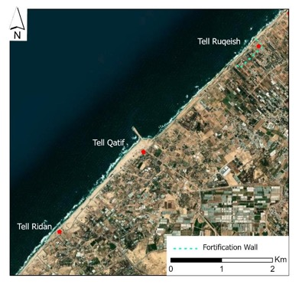This report outlines the results of the 2023 season, which took place between June and August 2023 and focused on the coast of Deir el-Balah and Khan Yunis, including the survey of the coastal Tell Ruqeish, Tell Qatif and Tell Ridan (fig. 1). Tell Ruqeish was partly surveyed in 2022, when we established that the coastal front of this Iron Age site likely extends to 600m and is accompanied by a monumental wall. In 2023, we extended our survey 4km to the SW, to include Tell Qatif, a site with reported Iron Age features, and Tell Ridan, an area with a reported Iron Age stone quay. Our aim was to determine the materiality of Iron Age maritime activities in this region, but also to examine the relation of the three sites as part of a large and significant Iron Age maritime landscape.

The 2023 season built on the skills of already trained students to conduct a more systematic documentation of maritime features. It also trained an additional 10 students pursuing degrees in archaeology and GIS at the Islamic University of Gaza.. In 2023 we also engaged more productively with the local communities, through community engagement events.

Figure 1 GAZAMAP 2023 Area of Investigation

# **Training**

In 2023, we used the same training package developed in 2022. Training was delivered to last years’ 11 students as a refresher and to an additional 10 students pursuing archaeology, GIS and coastal engineering at the Islamic University of Gaza. The training included:

1. General overview of maritime archaeology (aims, principles, methods).
2. Methods in recording underwater archaeological features.
3. Remote sensing applications, including satellite imagery analysis and geophysical survey.
4. Photogrammetry for the documentation of maritime archaeological features.
5. Aerial/drone Survey of maritime archaeological sites.
6. Introduction to the Honor Frost Foundation and study/scholarship opportunities.

Practical training included:

1. 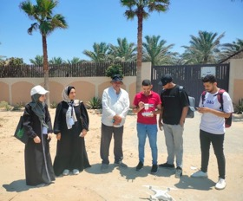Aerial survey (fig. 2) with the use of drone by Ain Media, a Gaza-based media company. Ain Media has been involved in the documentation of the Anthedon harbour in 2021 in collaboration with Forensic Architecture at Goldsmith University. The students learned how to plan and execute a survey and how to produce 3D models using photogrammetry software. Both our Ain Media partners, Ibrahim Lafti and Rusdhi Sarraj (an awarded photojournalist, [Rushdi Sarraj loved to record what others did not or would not see (economist.com)](https://www.economist.com/obituary/2023/10/26/rushdi-sarraj-loved-to-record-what-others-did-not-or-would-not-see)) were killed in October 2023.

Figure 2 Aerial survey training with Ain Media.

1. Data collection using Kobo Collect, an offline, open access spatial data collection app (https://www.kobotoolbox.org/). The survey team used KoboCollect to record field observations in the form of geotagged photographs, subsequently analysed using GIS.
2. 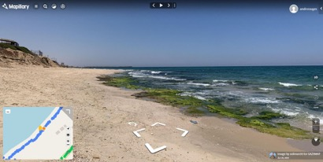The students received training on a new open access app collecting street-level imagery. Mapillary, an alternative to google street view, is typically used to document streets (fig.3). In Gaza, our team used it to collect and publish geotagged photographs of the beach and the exposed coastal scarp. The pictures form a baseline for future assessments of the condition of the coastline through regular monitoring. The collected imagery is available at: mapilary.com.

Figure 3 Example of imagery collected via Mapillary. A user can see both the precise location of the features and a photo. A user can also travel through various photos and examine the spatial relation of the documented features, as well as their association with modern structures.

# **Survey Results:**

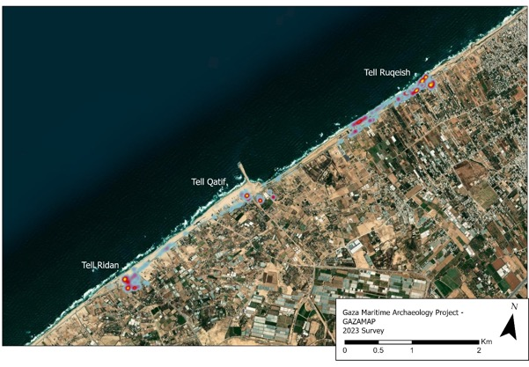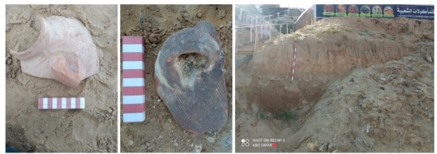The students walked systematically the coastal stretch connecting Tell Ruqeish, Tell Qatif and Tell Ridan, across which they noted consistent presence of ceramic finds (fig. 4). Over 3200 surface finds and features were noted, including ceramics, stone tools, bone and architecture. While many pottery sherds are severely abraded due to prolonged exposure, and thus their precise dating is not possible, a large number of large, more recently exposed and fragmented sherds were noted, with a date consistent with the 1st millennium BCE (fig. 5) - the period during which Tell Ruqeish was in use.

Figure 5 Left and Middle: Large fragments of recently exposed (likely eroded) pottery at Tell Ruqeish. Right: actively eroding mudbrick wall at Tell Ruqeish.

Figure 4 Map showing the density of surface archaeological finds. The yellow and red colours indicate high density. The blue indicates low density.

Notably, surface finds were documented in areas that have been drastically affected by modern development. The most powerful example is the beach of Tell Qatif, which is now Khan Yunis’ harbour, has been altered due to extensive land reclamation over the past decade and the construction of a quay (fig. 6).

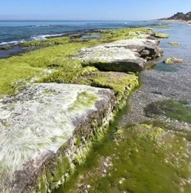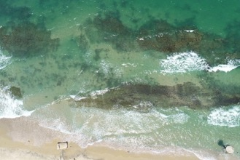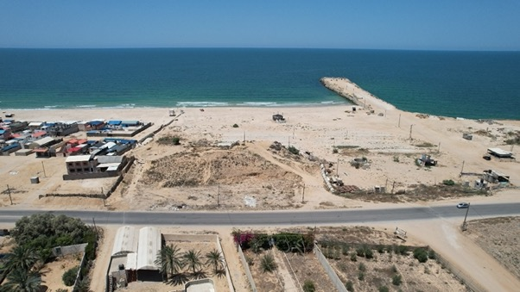Additional documented features include actively eroding mudbrick walls, as well as submerged features (cuts) (fig. 7). A more detail documentation of these features was planned in October 2023, but had to be postponed. The features remain mapped in a rudimentary manner, awaiting for further investigation when possible. Previous research suggested these features are an indication of sea level change, which is further attested in contemporaneous sites in the Southern Levant, such as Tell Dor in Israel (Yasur- Landau and Shalev 2022). Preliminary visits to the most accessible parts of these features have pointed evidence for tool marks, which could be related to ancient quarrying (fig. 8).

Figure 8 Preliminary photographs of selected features prior to detail documentation (originally planned for October 2023).

Figure 7 Submerged features found in association with fragmentary pottery between Tell Ruqeish and Tell Qatif.

Figure 6 Aerial photograph of the extent of visible archaeological features at Tell Qatif. The site is known largely for its Neolithic component. However, substantial Iron Age features were documented during the construction of the coastal road. Unfortunately, any underwater evidence is covered by sediment trapped behind the quay.

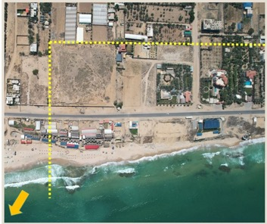About 50% of Tell Ruqeish is estimated to be eroded and under the water (fig. 9). Figure 9 indicates the extent of known architectural features (yellow dotted line). Any features found north of the coastal road have experienced substantial erosion. Additional features are found submerged, due to sea-level change (Morhange et al. 2005).

Approx. 250m

Figure 9 Close up to Tell Ruqeish. The dotted yellow line indicates the presence of a massive mudbrick wall documented since the 1970s.

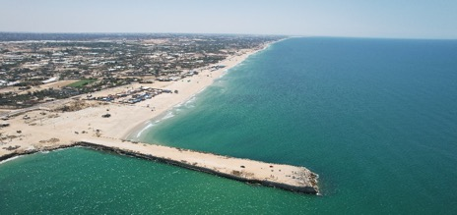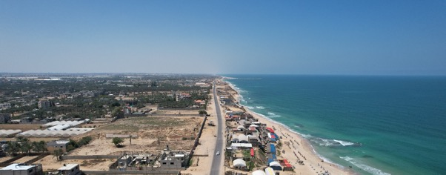Similar features have been mapped along the coastline between Tell Ruqeish and Tell Ridan (fig. 10). The least disturbed features are associated with Tell Ruqeish. Unfortunately, the beach of Tell Qatif and Tell Ridan have experienced changed due to modern development and we consider unlikely that any submerged features would be visible for documentation (fig. 11). This, of course, needs to be confirmed through underwater survey. Despite that, it is important to note that surface pottery is visible and abundant (fig. 4).

Tell Ridan

Tell Qatif

Figure 11 Aerial photograph showing the coastline between Tell Qatif and Tell Ridan. The coastline has experienced sedimentation since the construction of the pier (Khan Yunis harbour) in 2015-2016.

250m of visible mudbrick wall

Tell Ruqeish

Tell Qatif

Figure 10 Visible extent of submerged features.

# **Community Engagement events**

Following the completion of the surface survey, GAZAMAP organised community engagement events designed for different age groups. These events included a short presentation of the project and its scope, a conversation highlighting the historical and archaeological nature of Tell Ruqeish, and an exhibition with photos of Tell Ruqeish taken by Nic Flemming in the 1970s (fig. 12-13).

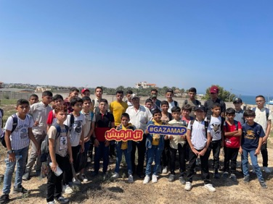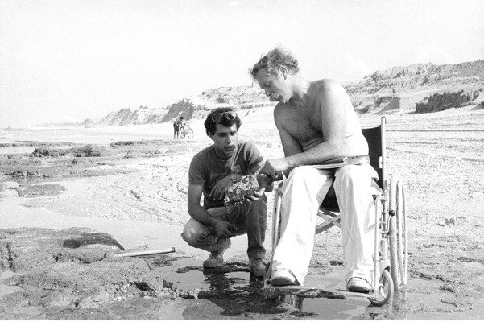Among the highlights of these events was conversations with people local to Deir el-Balah, who were present during the original excavations of Tell Ruqeish and even remembered meeting Nic Flemming. The events also attracted people familiar with Gaza’s underwater heritage (divers), who provided information on their observations in the area of investigation. One of our students (Tasneem) has been documenting the oral histories of Deir el-Balah. In October 2023 we were informed that Tasneem was in the hospital after her family home was demolished. We have since lost contact.

Figure 13 School visit at Tell Ruqeish with guided tours from members of GAZAMAP and members of the local community that witnessed the site's original excavations in the 1970s.

Figure 12 Photo of Nic Flemming at Tell Ruqeish in the 1970s (Nic Flemming archive, Hartley Libary, University of Southampton).

# **Collaborative research projects**

In March 2023 we submitted a successful funding application to the Cultural Protection Fund of the British Council (£73000) in collaboration with the London-based Palestine Exploration Fund (PEF). The proposed project, titled *Developing Capacities in Maritime Cultural Heritage Management and Protection* aims to deliver training on underwater surveying techniques to archaeology students and heritage professionals from the Gaza Strip (members of GAZAMAP) and Libya (partners from the Department of Antiquities). The training was planned to be delivered in Egypt in collaboration with the Alexandria Centre for Maritime Archaeology in 2024. It would be followed by the documentation of known submerged features along the coast of Deir el-Balah, which was surveyed in the summer of 2023. Due to the current situation, it is unlikely that our Gazan partners will be able to benefit from this research grant. We are currently exploring the most suitable way forward, which will include either postponing the project for one year, or reserving the amount allocated for Gaza for a later use.

# **Since October 2023**

Since October 2023, we have been monitoring closely the impact of the war on known archaeological sites. In this report, we are focusing largely on maritime archaeological sites, though heritage destruction is also extensively documented in the historic core of Gaza city. We unfortunately also need to report that one of our students (Moatasem Habeeb) and two of our partners from Ain Media (Rusdhi Sarraj, Ibrahim Lafti) have been killed during the course of the conflict. Moatasem, was an extremely hard working and ambitious archaeology student, who worked with us since 2022 and was going to receive maritime archaeological training in Egypt (CPF).

Our observations derive from a combination of satellite image analysis (Planet.com) cross-referenced with trusted local informants and relevant social media posts accompanied by photographs.

Based on these we observed that heritage in Northern Gaza has suffered the most. Satellite imagery in November clearly shows the bulldozing of long stretches of coastal land that facilitated military access.

The affected sites include:

1. **Anthedon** harbour, which spatially coincides with the modern Shati refugee camp. Anthedon includes exposed and excavated features dating from the Iron Age to the Byzantine periods. The density of archaeological features, most of which covered by modern architecture, but also the archaeological importance of the finds made Anthedon the most important site in the Gaza Strip. A testament to its local importance is Anthedon’s inclusion in the UNESCO tentative list ([Anthedon Harbour - UNESCO World Heritage Centre](https://whc.unesco.org/en/tentativelists/5719/)). In fact, MoTA suggested Anthedon as a suitable area for a comprehensive underwater survey by GAZAMAP. Anthedon was damaged by airstrikes in 2014 and 2021 (Andreou et al. 2022). The impact of the 2021 airstrikes is the most extensively documented ([Living Archaeology In Gaza ← Forensic Architecture (forensic-architecture.org)](https://forensic-architecture.org/investigation/living-archaeology-in-gaza).

Preliminary observations on satellite imagery before and after November 2023 clearly demonstrate the impact of airstrikes and subsequent clearance through bulldozing (fig. 14). Not far from Anthedon is the Al-Mathaf Museum, a private collection that in 2007 was transformed to an archaeological museum open to the public. While the building was certainly damaged, it has not been demolished. Trusted local sources informed us that the building was used as a military station. Some of the museum collections derive from the sea off Anthedon, which is known to local fishermen and divers as a source of antiquities.

Figure 14 Satellite image of Anthedon from September, October, and November 2023. In October, one notes widespread building destruction – in fact smoke is visible in the satellite image. In November, one can note that building rubble and the broader area was cleared.

1. **Maioumas** includes the Byzantine and Islamic components of the Gaza harbour, including historical buildings, traces of a “crusader” wall and reported surface pottery. In the recent years, this area developed into Gaza’s modern harbour, the construction of which has very likely removed any submerged features related to historical maritime activity. Nevertheless, MoTA informed us that archaeological features are a common occurrence during building and road construction and improvement works. In other words, substantial remains are presently below post-Medieval and modern structures. Based on news reports and social media posts, and confirmed through satellite imagery, Gaza’s harbour has been damaged by airstrikes, which caused the demolition of surrounding structures in October. By November, one notices on satellite imagery the clearance of rubble, which likely resulted in the removal of any remaining traces of antiquity in this area (fig. 15).

Other sites were damaged as part of the broader destruction of residential buildings. These include:

Figure 15 Satellite image of the known extent of known and dispersed archaeological features related to Maioumas. In November 2023 one notes extensive clearance south and adjacent to the modern Gaza harbour.

1. **Aerial view of a city

   Description automatically generatedTell es-Sakan** (fig. 16) the largest archaeological site in the Gaza Strip (fig. 17). While presently inland, Tell es-Sakan had access to the sea during the 4th and 3rd millennia BCE, when it was used firstly as an Egyptian colony (the earliest in the southern Levant) and subsequently as a Canaanite city. Fortunately, Tell es-Sakan was documented in 2022 by GAZAMAP. Satellite imagery from October 2023 demonstrates the destruction of multiple residential buildings within the broader archaeological landscape of Tell es-Sakan. Not far from Tell es-Sakan is Tell el-Ajjul, which is one of the most extensively discussed sites in archaeological literature.

Figure 16 Map of important Bronze Age archaeological sites around Wadi Gaza.

1. Aerial view of a city

   Description automatically generated with medium confidenceA satellite image of a land

   Description automatically generatedAerial view of a city

   Description automatically generatedThe Late Bronze Age **Tell el-Ajjul** and the neighbouring Middle Bronze Age **al-Moghraqa** occupy a rich landscape currently being used for agricultural purposes. While no craters can be identified in the excavated (and since the early 2000s backfilled) components of the sites, buildings located within the broader extent of the site have been bombed (figs. 18-19).

Figure 19 Satellite image of al-Moghraqa from September 2023 (left) and November 2023 (right). Clearance and building demolition can be observed within the known extent of archaeological features.

Figure 18 Satellite image of Tell el-Ajjul. The site has been impacted by airstrikes, which destroyed modern structures within the known extent of archaeological features.

Figure 17 Satellite image of Tell es-Sakan in September 2023 (left) and November 2023 (right). Part of the site has been destroyed due to building demolition and debris.

1. The same applies for the Chalcolithic **Taur Ikhbeina**, the broader area of which, including a building adjacent to the tell has been impacted by airstrikes. Due to restriction, the resolution of available satellite image is very low. As a result, it is not always possible to determine the extent of damage. Though it is often possible to determine that a building has been damaged, the broader impact of this damage (e.g. extent of rubble), while substantial, is not visible.

The coast of Deir el-Ballah with which the GAZAMAP team became familiar of the past two years has also been affected by the war even before the extension of military operations south of the Wadi Gaza. Since October, the beach of Tell Ruqeish was used as a refuge by displaced populations, and it often appears in social media posts (fig. 20).

Figure 20 Instagram posts by Hind Khoudary (17 December 2023) showing the beach of Deir el-Balah, which stretches between Tell Qatif and Tell Ruqeish.

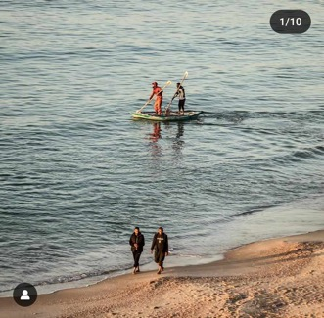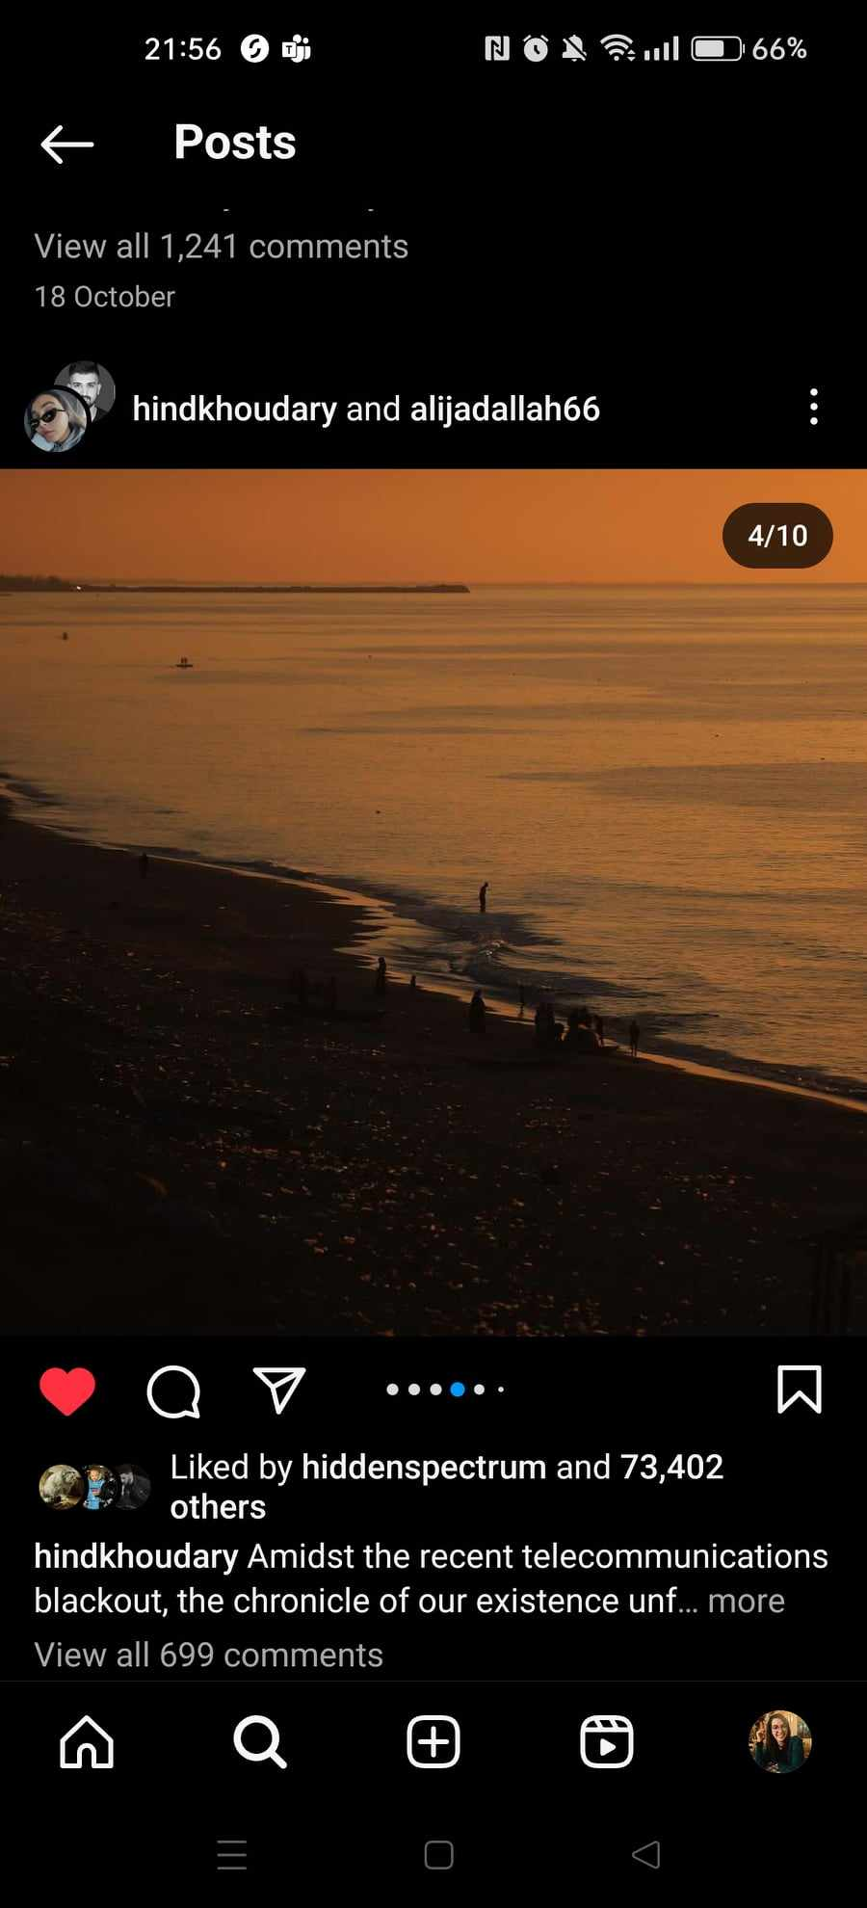

1. Tell Ruqeish is the Iron Age fortified citadel with submerged features documented by GAZAMAP in 2022 and 2023. While no definitive damage or destruction can be observed in the available low resolution satellite image, social media videos circulating in early in November 2023 show extensive fire burning temporary structures (Layali Zaman café) located on the coastal segment of Tell Ruqeish. This fire has likely burned the surface of the site, possibly impacted the extensive mudbrick walls, and potentially further contributed to the future erosion of this extremely vulnerable site (fig. 21).
2. Changes in the landscape of **Tell Qatif** can also be observed in satellite image and while we cannot confirm what they are related to, trusted sources informed us that this area has also been affected by airstrikes. These changes have been picked up as damage by comparative maps produced by the United Nations Satellite Centre ([UNOSAT](https://unosat.org/products/3769)). We believe that information will become clearer in the next few weeks when we can access more recent imagery from Tell A beach with a body of water

   Description automatically generatedA fire in the night sky

   Description automatically generatedQatif and **Tell Ridan**.

Figure 21 Instagram posts from Tell Ruqeish. These represent still shots of videos produced by Mohammed Alnaouq, the owner of the Layali Zaman cafe, which is located on top of Tell Ruqeish. A massive fire has destroyed the coffee shop partly located on the mudbrick walls of Tell Ruqeish.

# **Media**

The Gaza Maritime Archaeology Project has attracted media attention before and after October 2023. In August 2023, Georgia Andreou gave was interviewed by the Middle East Monitor ([The fight to save the Middle East’s heritage: MEMO in conversation with Georgia Andreou – Middle East Monitor](https://www.middleeastmonitor.com/20230816-the-fight-to-save-the-middle-easts-heritage-memo-in-conversation-with-georgia-andreou/)). In November 2023, we provided information to the Art Newspaper ([Bombing of Gaza has damaged or destroyed more than 100 heritage sites, NGO report reveals (theartnewspaper.com)](https://www.theartnewspaper.com/2023/11/28/bombing-of-gaza-has-damaged-or-destroyed-more-than-100-heritage-sites-ngo-report-reveals) and [heritage-sites-destroyed-in-israel-hamas-war](https://www.theartnewspaper.com/2023/12/22/gaza-city-archives-among-heritage-sites-destroyed-in-israel-hamas-war)  (the artnewspaper.com).

# **Conclusions**

Since 2022, our project demonstrated that the most efficient and sustainable way to monitor sites in Gaza is to incorporate accessible and low-cost technologies in archaeological training and establish interdisciplinary collaborations with the private sector. GAZAMAP leveraged expertise dispersed across sectors through the development of a collaborative network in conjunction with customisable open access technologies to address the unique monitoring challenges of each site.

By reinforcing these partnerships through continuous training of heritage students and professionals, we foresaw that our Gazan partners would take the lead in conducting surveys and utilising accessible and open-access tools to document the ongoing devastation of their heritage. Combined with training in underwater heritage documentation (CPF grant), there was substantial potential to document large and important concentrations of underwater features both in Deir el-Balah, and in Northern Gaza (Anthedon).

# **Cited References**

Andreou, G.M., M. Fradley, L. Blue and C. Breen 2022. Establishing a baseline for the study of maritime cultural heritage in the Gaza Strip. *Palestine Exploration Quarterly*. DOI: 10.1080/00310328.2022.2037923

Morhange, C., M. H. Taha, J.-B. Humbert and N. Marriner 2005. Gaza: Évolution des Environments et Occupation de l’Espace Depuis l’Âge du Bronze. *Revue Géographique des Pays Méditeranées* 104: 75–78.

Yasur-Landau, A. and E.A. Shalev 2022. The date of Tel Dor well and its contribution to the study of sea-level changes. In U. Davidovich, N. Yahalom-Mack and S. Matskevich (eds.), *Material, Method, and Meaning. Papers in Eastern Mediterranean Archaeology in Honor of Ilan Sharon.* Ägypten und Altes Testament 110. Münster: Zaphon: 177-182.